**Experiment No 7**

**Implement and write advantages of Poly-alphabetic Cipher.**

#include <iostream>

#include <string>

using namespace std;

string to_up(string s)

{

int i = 0;

string st = "";

while (i < s.size())

{

st += toupper(s[i++]);

}

return st;

}

string encrypt(string plaintext, string key)

{

string ciphertext = "";

int keyLength = key.length();

for (int i = 0; i < plaintext.length(); i++)

{

char plainChar = plaintext[i];

char keyChar = key[i % keyLength];

char cipherChar = (plainChar + keyChar) % 26 + 'A';

ciphertext += cipherChar;

}

return ciphertext;

}

string decrypt(string ciphertext, string key)

{

string plaintext = "";

int keyLength = key.length();

for (int i = 0; i < ciphertext.length(); i++)

{

char cipherChar = ciphertext[i];

char keyChar = key[i % keyLength];

char plainChar = (cipherChar - keyChar + 26) % 26 + 'A';

plaintext += plainChar;

}

return plaintext;

}

int main()

{

string plaintext;

string key;

cout << "Enter the message : ";

getline(cin, plaintext);

cout << "Enter the key in text format: ";

cin >> key;

plaintext = to_up(plaintext);

key = to_up(key);

string ciphertext = encrypt(plaintext, key);

cout << "Ciphertext: " << ciphertext << endl;

string decryptedText = decrypt(ciphertext, key);

cout << "Decrypted Text: " << decryptedText << endl;

return 0;

}

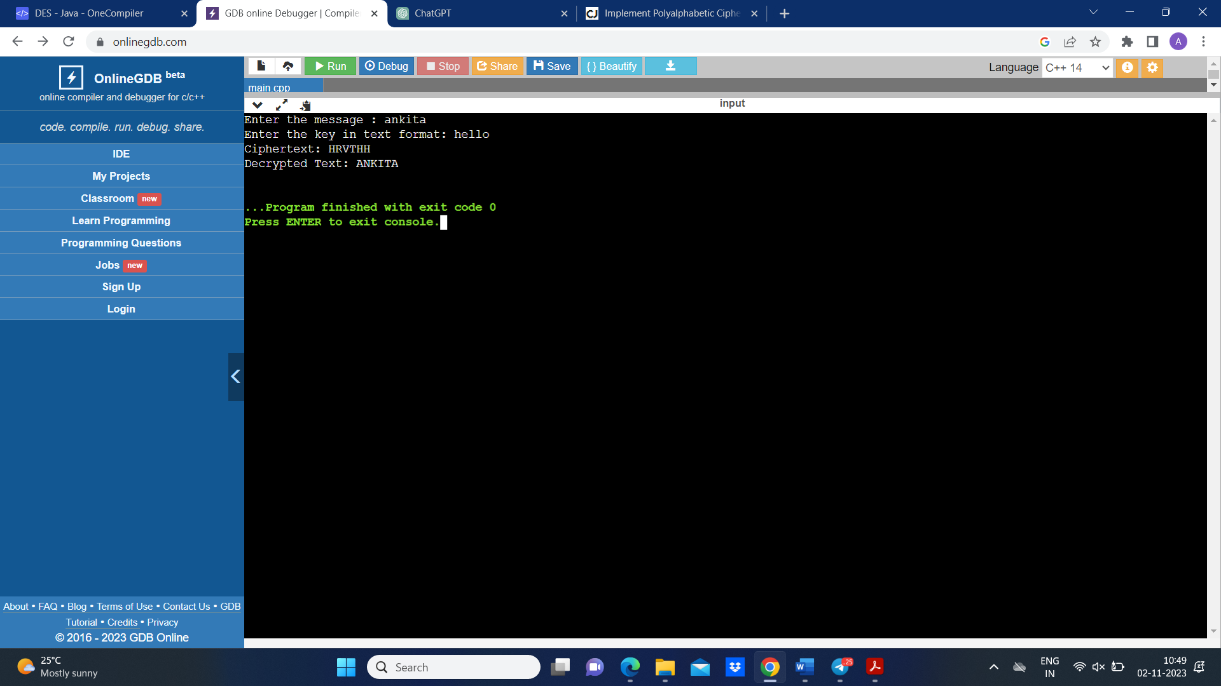**Output-**